EMBODIES REALITIES
In the third Witness Performance essay for BLEED, Alison Croggon explores the ongoing evolution of virtual worlds. Beginning with the invention of representation and the simultaneous invention of the incorporeal self, she explores the presences that linger and embody themselves through our physical absences
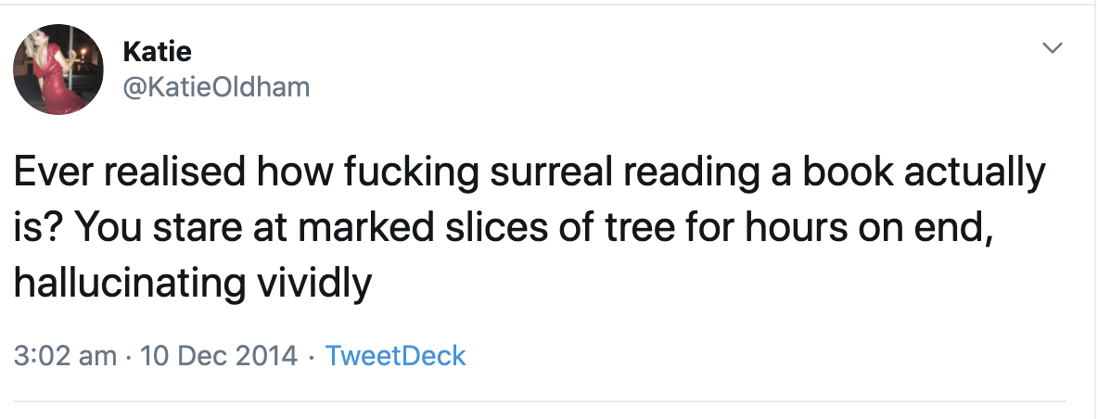
https://twitter.com/KatieOldham/status/542348626711019520
Speaking is a profoundly visceral act. It begins deep in the body: a short breath in is followed by a long exhalation. Travelling through the larynx, the expelled air is converted into intermittent pulses that create a buzzing sound, which in turn is amplified by resonators in the pharyngeal, oral, and nasal cavities. These vibrations are finally shaped into articulated sounds by the tongue, lower jaw, lips, and velum.
I type these words in silence but the echoes of their fleshliness persist, ghostly lips and tongues forming their sounds in my mind. Even in the act of writing, materiality insists itself: the words appear on a screen that sits solidly before me, my fingers running lightly over the keyboard. I see the shapes of them, black on white.
These words, which originated in the deepest recesses of my body, are now separate from me. They’re abstractions that will be sent as electrical pulses to another computer, where they will manifest on other screens or perhaps on pages in a book. They will be read by other people, registering in their own bodies.
Do they any longer have anything do with me? I want to say yes, even as I know how attenuated the connection is. The words I write are the echo of an echo: the mental echo of a physiological process, now transformed in another body, another mind, to become other than me.
Writing means that we don’t need to be present to speak. We can send the echoes of our bodies through time and space, igniting these ghosts of our selves in the bodies of other people, even after we are dead. Our written words can be experienced silently through our vision or perhaps through fingers as braille or even listened to, but we will not be there. It’s an experience of physical absence that’s so naturalised we barely notice how strange it is.
Devising writing systems has had profound implications for our species, in particular for our memories, both individual and cultural. Because of the written word, we can read the story of how the goddess Innana, Queen of Heaven, travelled to the underworld to challenge her sister Erishkigal, Queen of the Dead, 4000 years after it was told in ancient Mesopotamia, or the idle musings of a tweeter on the other side of the planet written 30 seconds before.
There’s a strange feeling of scandal inherent in the fact of written language. It’s an outrageously intimate connection, an internal process that becomes a public act. It’s not hard to understand why words have sometimes been thought of as sacred. And it’s equally easy to see why the word – especially the written word – has so often been thought of as blasphemous. Language, as Laurie Anderson said, is a virus.
Language creates worlds, transcends our selves. In the Christian tradition, it’s primodial consciousness: the Gospel of John opens with: “In the beginning was the Word, and the Word was with God, and the Word was God.” Writing is a form of necromancy: it means that I can read the thoughts of people who are long dead. Words are their own kind of magic: spells might be written down but they must be spoken out loud. Writing enchants and transforms us: it can, as we say in that seemingly innocuous phrase, “change our minds”.
Without language, there can be no truth. Only language makes it possible to lie, to say things are other than they are. Without even the physical presence of the speaker, without the context of our bodies together in the same space, ideas of truth and falsity become ever more attenuated. We invent fictions. We say that those fictions are truthful. Sometimes our fictions are indeed more truthful than some factual accounts.
Writing is the original virtual reality. This is perhaps why the alienations of the digital age have never seemed especially strange to me. I’m a wordcentric person, a professional writer whose life has always been mediated by these disembodied abstractions. To me, digital life has always seemed to me like the next turn of a revolution that began 60,000 years ago.
The oldest known writing appeared about 5500 years ago in Sumer, now Iraq, when early pictorial signs were gradually substituted by a complex system of characters representing the sounds of Sumerian and other languages. According to the British Library, full writing-systems – the coding of speech – have been invented independently at least four times in human history: first in Mesopotamia as cuneiform between 3400 and 3300 BCE, shortly afterwards in Egypt at around 3200 BCE, in 1300 BCE in late Shang-dynasty China and between 900 and 600 BCE in the cultures of Mesoamerica.
Relatively speaking, writing is new. The oldest writing is pictograms, because human being were creating pictures long before they thought of writing down words. The oldest securely dated cave painting is a red hand stencil in Maltravieso cave, Cáceres, Spain, made by a Neanderthal more than 64,000 years ago. It’s likely that the rock paintings at Nawarla Gabarnmung, a site in south-western Arnhem Land traditionally owned by the Buyhmi clan of the Jawoyn people, goes back almost as far, as painting tools have been discovered nearby that have been dated back to 60,000 years.
The urge to represent, to create realities that exist beyond the body – abstractions that describe relationships between each other and our wider worlds – is, literally, an ecstatic urge. The word ecstasy originates from the ancient Greek, ek, meaning “outside” or “beyond”, and stasis, meaning “standing” or “stationary”. There is movement in all our meaning making, the urge to move our selves elsewhere, even beyond ourselves. The OED says that in later Greek, the meaning transformed to a “withdrawal of the soul from the body, mystic or prophetic trance”.
For oral cultures such as the First Nations of Australia or ancient Greece, words are corporeal memory, passed on from one mouth to another. Cultural memory is literally embodied in the singer, whether it was the anonymous singers who told the cycle of stories that were eventually written down as Homer’s Iliad or Odyssey, or the songspirals related by First Nations peoples.
One of the major losses in literate societies is the capacity of individual memory, a tendency accelerated by the internet. In modern literate societies, we outsource our memories to libraries and archives, real or virtual. In oral cultures, the knowledge must be held in the body and presence of each custodian.
In an oral society, tradition is preserved in “ritualised utterance”, poetic speech, which is memorised and passed on to others. First Nations songspirals still retain the first function of poetry, which was to preserve cultural tradition and knowledge. The feats of memory are prodigious: oral cultures catalogue vast amounts of knowledge. In literate societies this has mostly been lost, relegating poetry to a form of entertainment, although for some of us it still retains a sense of that original significance: a ghost of ritual, an echo of ceremony.
In Songspirals: Sharing women’s wisdom of Country through songlines, the Gay'wu Group of Women, Yolŋu women from North East Arnhem Land, describe these songspirals as patterns as complex as the human body itself:
Songspirals are often called songlines or song cycles. In this book, we call them songspirals as they spiral out and spiral in, they go up and down, round and round, forever. They are a line within a cycle. They are infinite. They spiral, connecting and remaking. They twist and turn, they move and loop. This is like all our songs. Our songs are not a straight line. They do not move in one direction through time and space. They are a map we follow through Country as they connect to other clans. Everything is connected, layered with beauty. Each time we sing our songspirals we learn more, go deeper, spiral in and spiral out.
This sinuous, many-ended, open complexity is a function of the direct relationship this language has to physical embodiment and corporeal memory. In his study of the transition from orality to literacy in Classical Greece, The Muse Learns to Write, Eric A. Havelock describes what happens when you write things down. “Once inscribed, the words in a document become fixed, and the order in which they appear is fixed,” he says. “All the spontaneity, mobility, improvisation, the quick responsiveness of spoken speech vanishes.”
In a literate society, this “fixed verbal disposition” is the primary instrument for preserving tradition: it is the primary means of our governance, our laws and our cultural memory. What does this “fixing”, this excavation of words from directly embodied presence into a status of object, do to human consciousness?
The sense of sight begins to play in the realm of language. The mind’s interior is foregrounded, becoming a recognisable space. We invent abstractions – justice, truth – and begin to manipulate our realities using those same invented concepts. We begin to order things in a linear fashion, as sentences do.
In her book Eros the Bittersweet, the poet Anne Carson writes about how the oldest Greek texts have no spaces between words, so all the words run together, as they do when we speak, and how the alphabet encloses space, inside and outside the letter, creating edges. Spoken language doesn’t have edges, it breathes and blurs and repeats and runs together and peters out. Speech has our whole bodies to create meaning; but outside our bodies, the written word inscribes exactness.
“Texts are the formal productions of disembodiment, a reduction of embodied communication as an interactive process into disembodied products,” says Matthew A. Killmeier in his 2009 paper The Body Medium and Media Ecology. “With disembodied texts, communication becomes detached from its moorings in particular spatial, temporal and sociocultural milieu – its contexts.” He says that the modern creation of texts – Killmeier dates modern society from the European Enlightenment – atomises our concept of society into individuals, and undermines the enchanting and ritualised aspects of embodied communication.
Interestingly, Killmeier also distinguishes between monologic and dialogic texts:
Dialogically structured media provide for the exchange of expression and are therefore characterized by relatively greater embodiment. They constitute users as participants. Whether a medium is monologic or dialogic is not only a matter of the medium as a formal means of expression, but also its political economic architecture. Radio, as Bertolt Brecht pointed out, could be organized dialogically, which would open up radically different socio-political potentials.
The tensions between linear and oral arrangements of meaning are very evident in live performances of plays and are, in fact, a major source of their vitality. The corporeal presence of actors and audience members, the physical architectures of space and light, the temporality of performance itself, open different axes of meaning and new fluidities within written texts. Skilled playwrights draw on these possibilities, bringing them to life as possibilities in their work.
The truth is that almost every culture exists between between the overlapping, contested possibilities of absence and presence, between dialogues and monologues, and have for millennia.
Perhaps the most interesting aspect of the digital age is the increasing dominance of its dialogic structure. It’s most notable in social media, but we see it in many activities: online gaming, live streamed participatory performance, dialogic online teaching models and so on. Much of the short history of the internet is, in fact, the ongoing conflict between monologic and dialogic structures of authority: the traditional broadcast model, versus the participatory notion of user-generated content.
Old lines of authority have fractured as new voices, previously filtered out of the public sphere, inscribe their realities. The social movements of Black Lives Matter, disability rights or #MeToo are impossible to imagine without this fluidity of exchange. As, indeed, are the increasing visibility of right wing extremism, Qanon conspiracy theorists and Men’s Right Activists. We always bring who we are into what we make, and the desire for change inspires resistance from those who prefer the world to be simpler.
But our worlds, our human worlds, have never been simple. For 60,000 years, ever since we discovered how to represent the world, how to create meanings that persisted beyond our physical presences, we have existed between many different ways of speaking and being. Perhaps the digital age offers us a larger possibility of cultural embodiment than has been possible for hundreds of years. We just have to recognise it.
This Witness Performance essay was commissioned by Arts House, City of Melbourne and Campbelltown Arts Centre and forms part of BLEED 2020, presented in partnership with Campbelltown Arts Centre.

