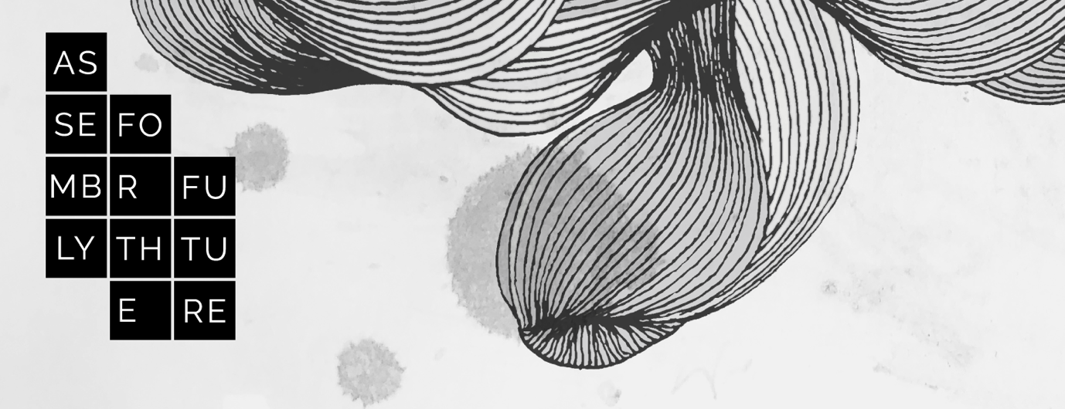
IMAGE DESCRIPTION: The words "Assembly for the Future" are to the left of the screen in descending black boxes overlaid across an abstract monochrome background of ink-like blotches and black lines evoking a hot air balloon, wind or waves.

Assembly for the Future - BLEED 2020

Access Guide

As part of the aspirational and values driven nature of Assembly for the Future, our intention has always been to embed access into the design and ethos of the project. To this end we see access services and accessibility as part of the project aesthetic and are visible for all audiences, not just provided for those who need them or tagged on after the project has been designed. We have been consulting closely with Access Consultants Will McRostie and Jess Kapuscinski-Evans throughout the two-year development of the project.

Assembly for the Future takes place in digital environments, in live and recorded formats, and a variety of methods will be used to make content accessible.
- Live Auslan interpretation and recorded Auslan interpretation
- Live captioning and closed captioning
- Transcripts of audio content
- Alternate-format versions of written text compatible with Screen Readers

Bookings and Enquiries
You can discuss your specific access needs by calling BLEED Ticketing on 02 4645 4100 between 10am and 4pm daily or emailing bleed@bleedonline.net.
If you need to, you can reach the Ticketing and Registrations team through the National Relay Service (relayservice.gov.au) at no additional charge.
- TTY users: phone 13 36 77 then ask for Box Office
- Speak and Listen users: phone 1300 555 727 then ask for Box Office
- Internet relay users: connect to the NRS (internet-relay.nrscall.gov.au) then type in Box Office

Accessibility Toolbar
Assembly for the Future is accessed via the BLEED website, which has been designed with a variety of accessible viewing modes. These options can be selected using the accessibility toolbar toggle on the upper right hand side of every page.
Accessibility toolbar toggling that allows you to set:
- Resize font (increase/decrease)
- Grayscale
- Negative Contrast
- High Contrast
- Light Background
- Links Underline
- Readable Font

Live (Open) Captions and Auslan Interpreting
Live (or Open) Captions provides real-time transcription of spoken English into written English displayed on screen during a live event or recorded live. For live events presented using Zoom, live closed captions can be accessed using the “CC” button within Zoom, or in a browser using a URL provided.
Auslan interpreters will provide live translation of spoken English into Australian sign language (Auslan).
Live Captioning and Auslan Interpreters will be available for the series of three Assembly for the Future events.
Assembly for the Future: Beyond Whiteness – The Rise of New Power
12pm – 2pm, Thurs 9 July
Assembly for the Future: Somewhere Everywhere, Right Here – Global Struggle Comes Home
12pm – 2pm, Thurs 23 July
Assembly for the Future: The Last Disabled Oracle
10am – 12pm, Thurs 6 August

Virtual Zoom Backgrounds – Image Description

At the Assemblies, speakers, crew and moderators will be using a Virtual Background. This will be a version of the image banner at the top of this document – an abstract background of ink-like blotches and lines - in red or black - evoking a hot air balloon, wind or waves, with the words "First Speaker” or “Respondent” or “Usher” or “Keeper of Time” or “Moderator” to the left of the screen in descending black boxes. The intention is to aid a fanciful, imaginative and playful tone at the event.

Access Monitoring

Our online Usher, Robbie, will be Access Monitoring during the Assembly, to ensure all access services working. He will watch the Live Captioning and Auslan Interpreters throughout the event and halt proceedings should a feed drop out.

If you experience technical difficulties during one of our events:
- use the Zoom Chat function to alert Robbie The Usher, or
- Call or text Producer, Sophia on 0417 286 254.

Recorded Events with Closed Captioning and Auslan Interpretation

Each of these events will also be recorded and made available online with Auslan interpretation and Closed Captioning 6 days following each live event:
Assembly for the Future: Beyond Whiteness – The Rise of New Power
Recording available from 15 July
Assembly for the Future: Somewhere Everywhere, Right Here – Global Struggle Comes Home
Recording available from 29 July
Assembly for the Future: The Last Disabled Oracle
Recording available from 12 August
For recorded content, closed captions can be accessed by clicking the “CC” button in the Vimeo player.

Image Description, Text transcripts and Text-only formats

Image description, transcripts of audio content and plain-text versions of written content will be available via links on the following event pages:
Assembly for the Future: Beyond Whiteness – The Rise of New Power
Provocation from the Future by Claire G Coleman available from 16 July
Assembly for the Future: Somewhere Everywhere, Right Here – Global Struggle Comes Home
Provocation from the Future by Scott Ludlam available from 30 July
Assembly for the Future: The Last Disabled Oracle
Provocation from the Future by Alice Wong available from 13 August

